**PROJECT REPORT**

*Virtual classroom and E-learning platform*

Submitted By

Name: Nithisha Joshfin Registration No. : 12309464

Name: Samala Hariprasad Registration No. : 12309909

Name: Thoufik Umar Registration No. : 12304034

COURSE CODE:- CSE326

*Under the Guidance of:-*  BRIJENDRA PAL SINGH

**School of Computer Science and Engineering**



*S*

**Introduction**

I have made this project using HTML, CSS & JavaScript.

“**home.html**” file is the core file which has all the other files linked to it.

Core code of the website is written in HTML & CSS is used to provide style to website & JavaScript is used to add logic to the website.

Specifically, JavaScript is used to check the internet connection and calls the function when the home page loads.

* **I have divided Homepage into 7 Major Sections:**

1. 1st One is “Home” which shows our homepage when someone clicks our website link.
2. 2nd One is “Technical Courses” which contains all the technical courses.
3. 3rd One is “Non-Technical Course” which contains all the non-technical courses.
4. 4th One is “About Us” which shows about us.
5. 5th One is “Contact” which shows our contact information.
6. 6th One is “Sign Up” which is used to sign up new users.
7. 7th One is “Login” which is used to login new members.

**Results (screenshots):**

HOME:-

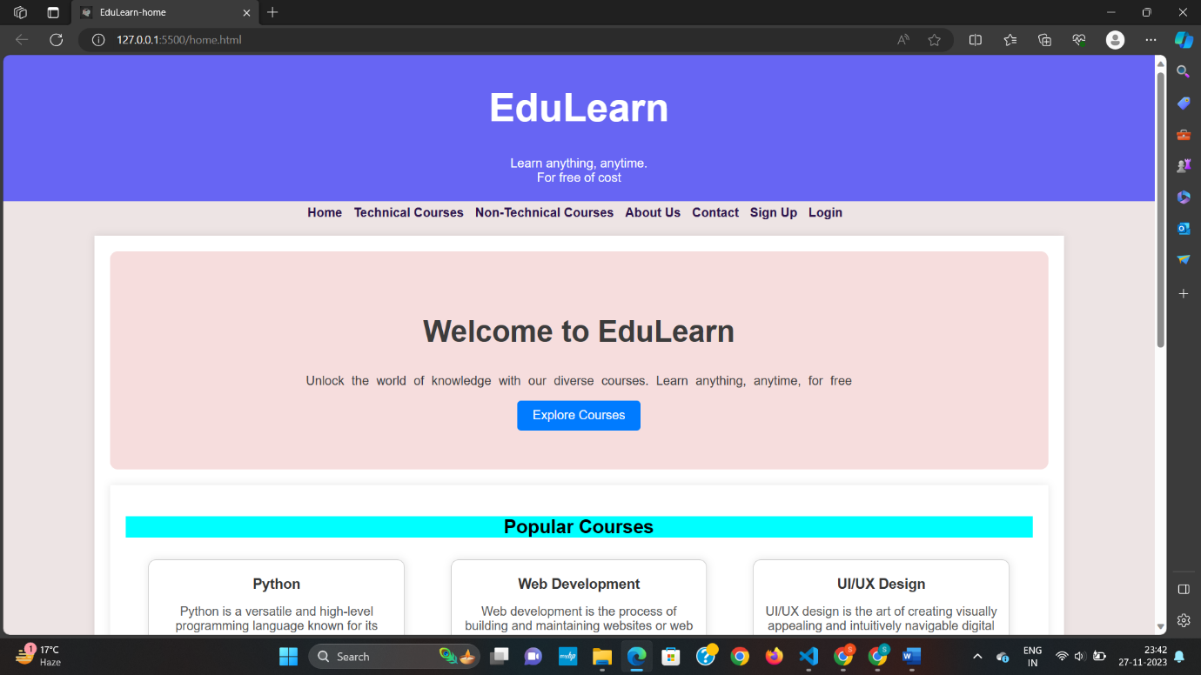

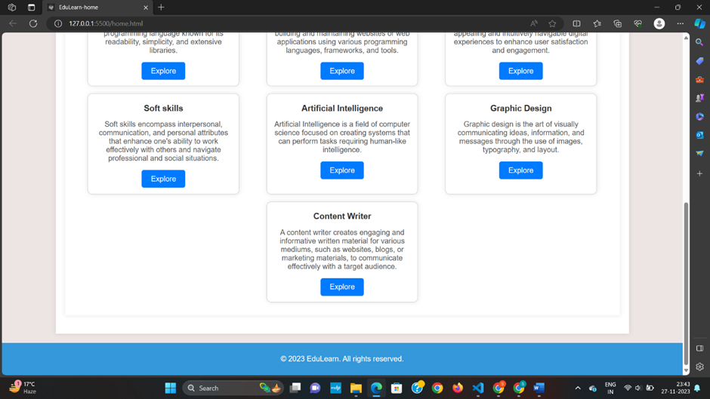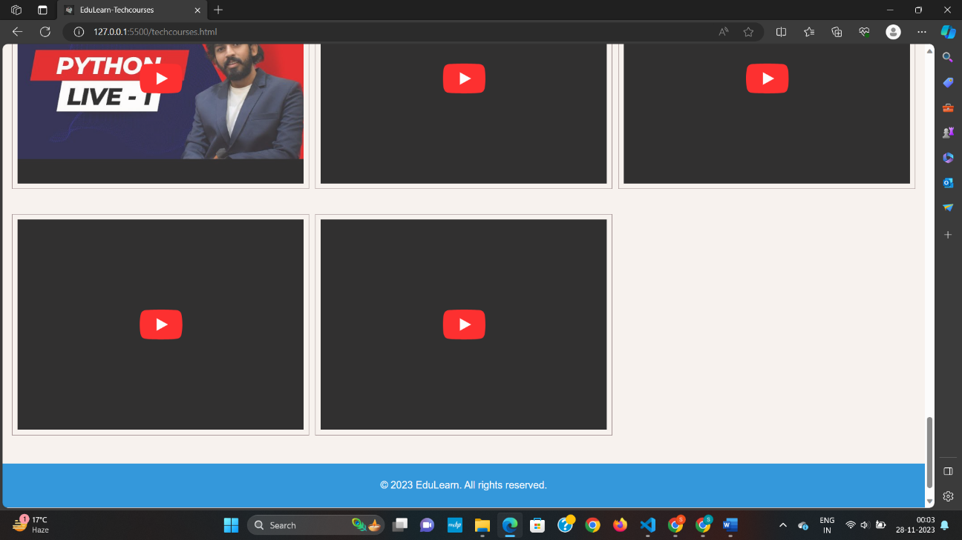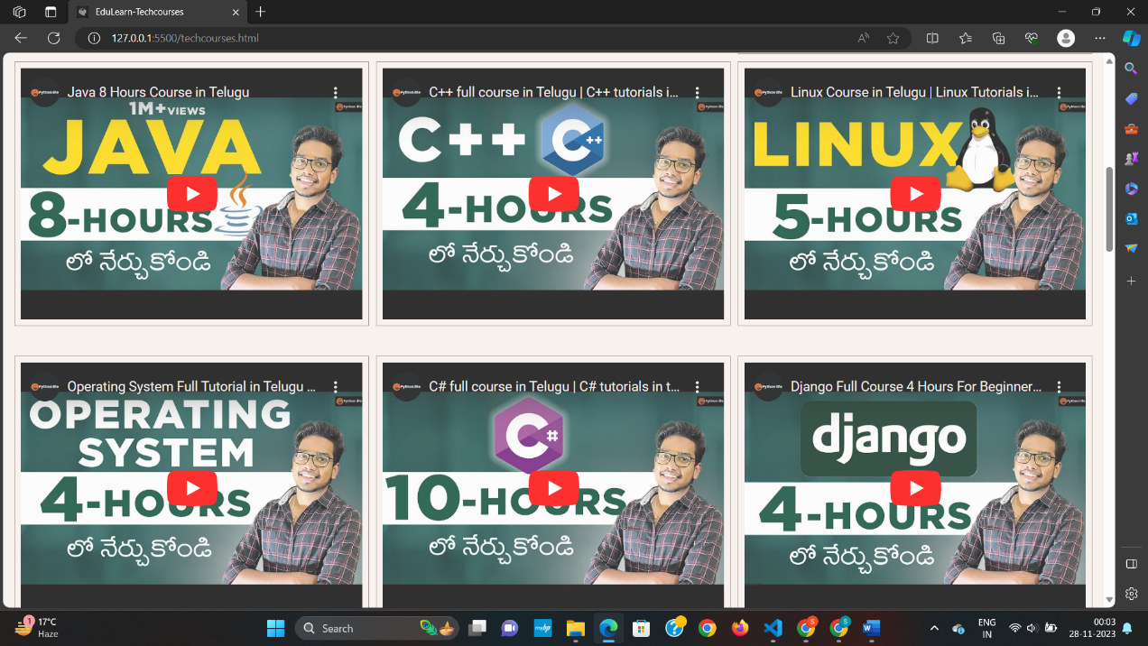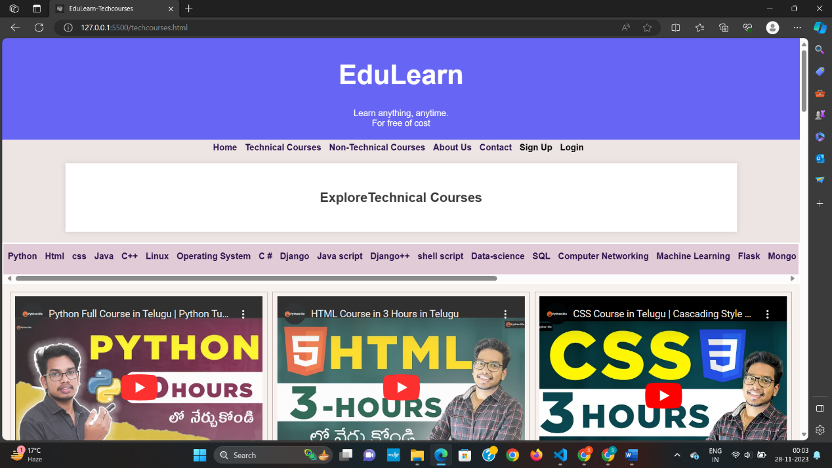Technical Courses:-

Non Technical Courses:-

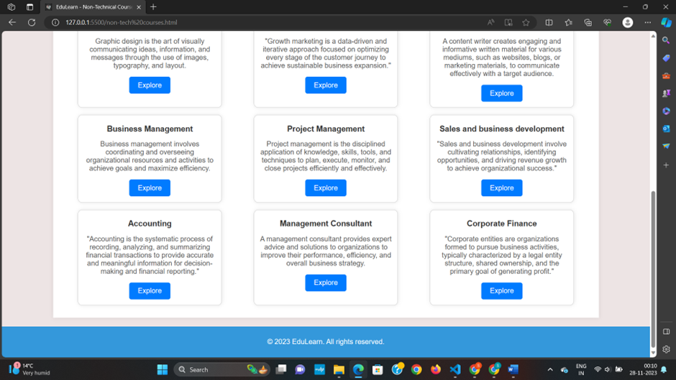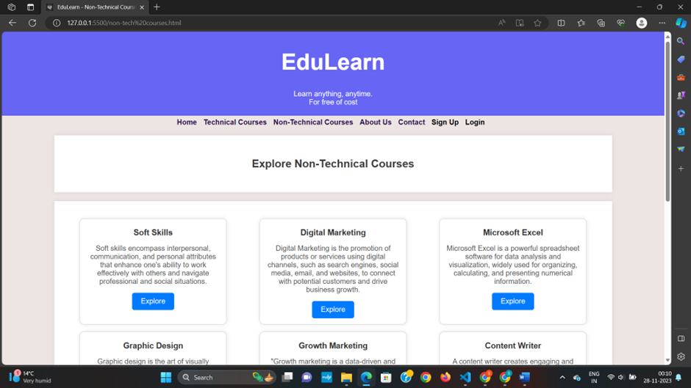

About Us:-

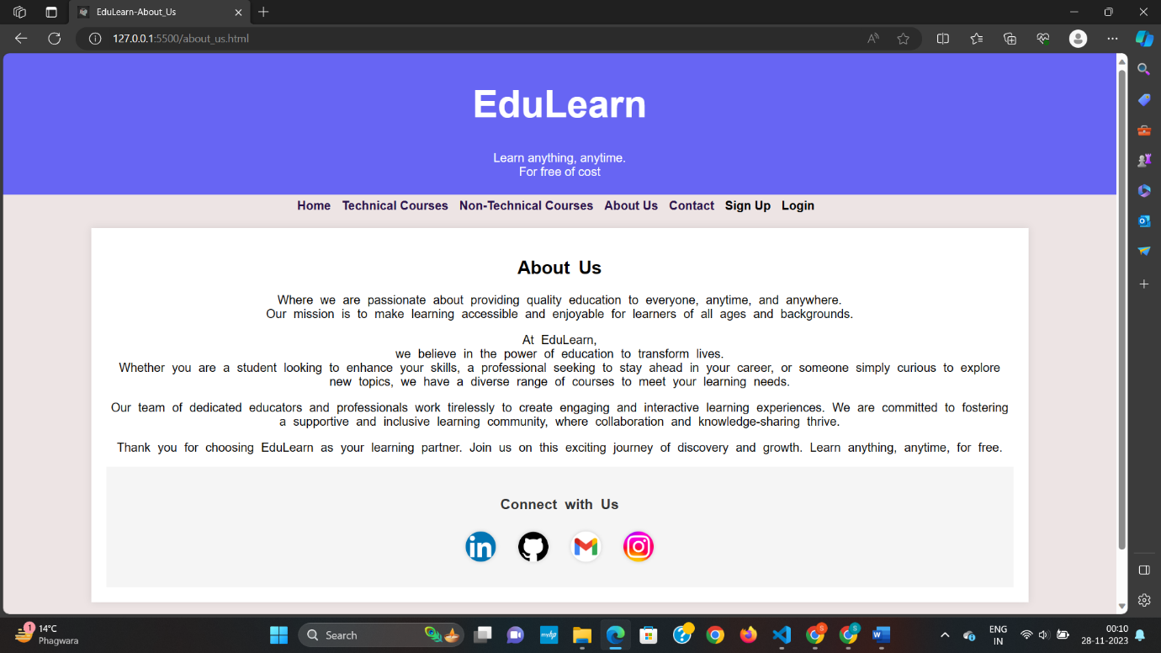

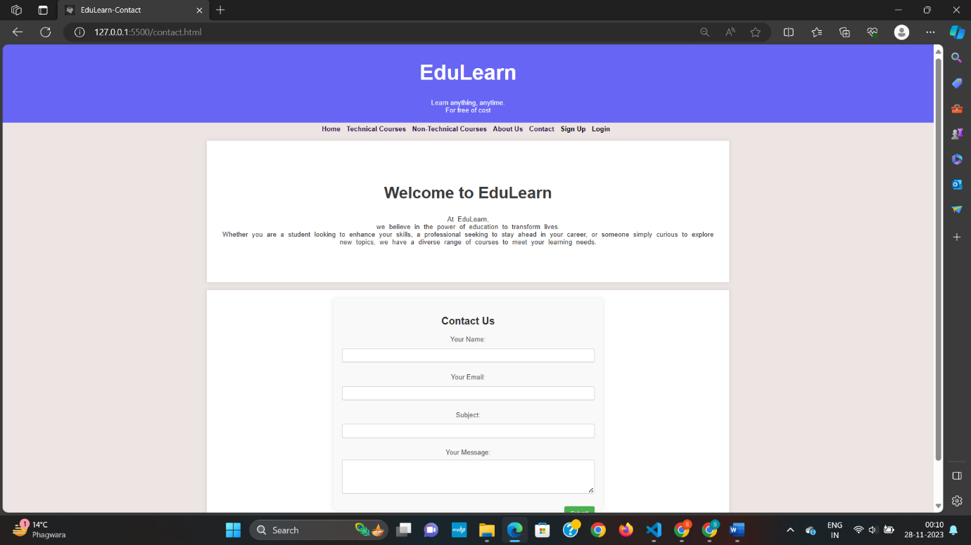Contact:-

Sign-up:-

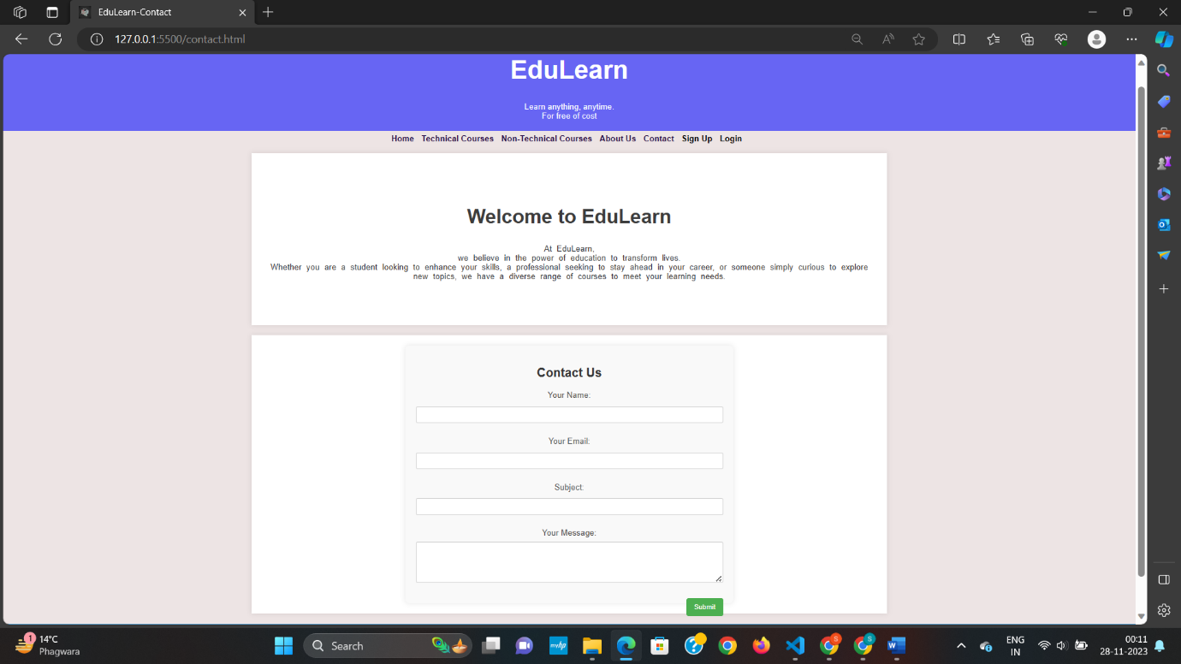

Login:-

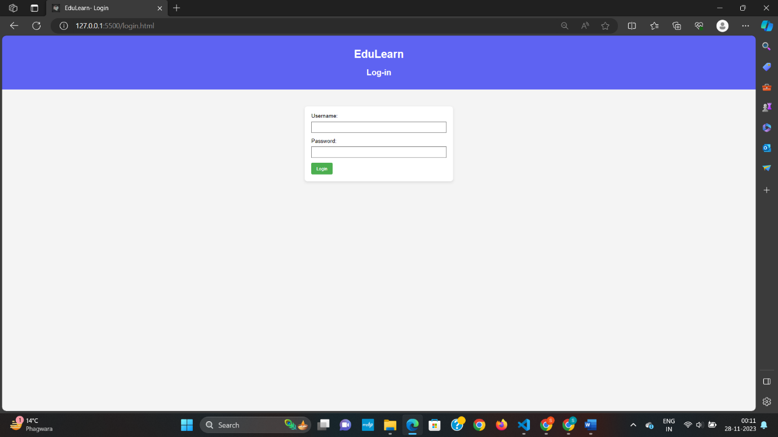

CODE :-

HTML , CSS and JavaScript Part:

* 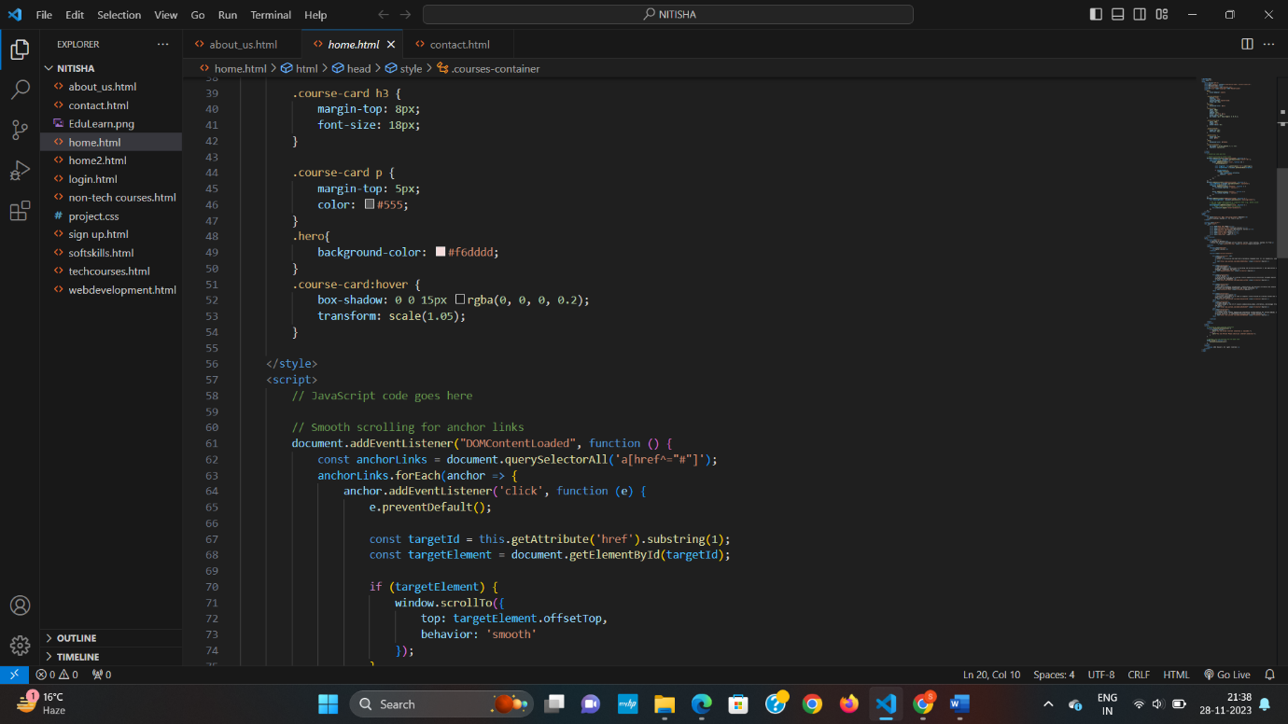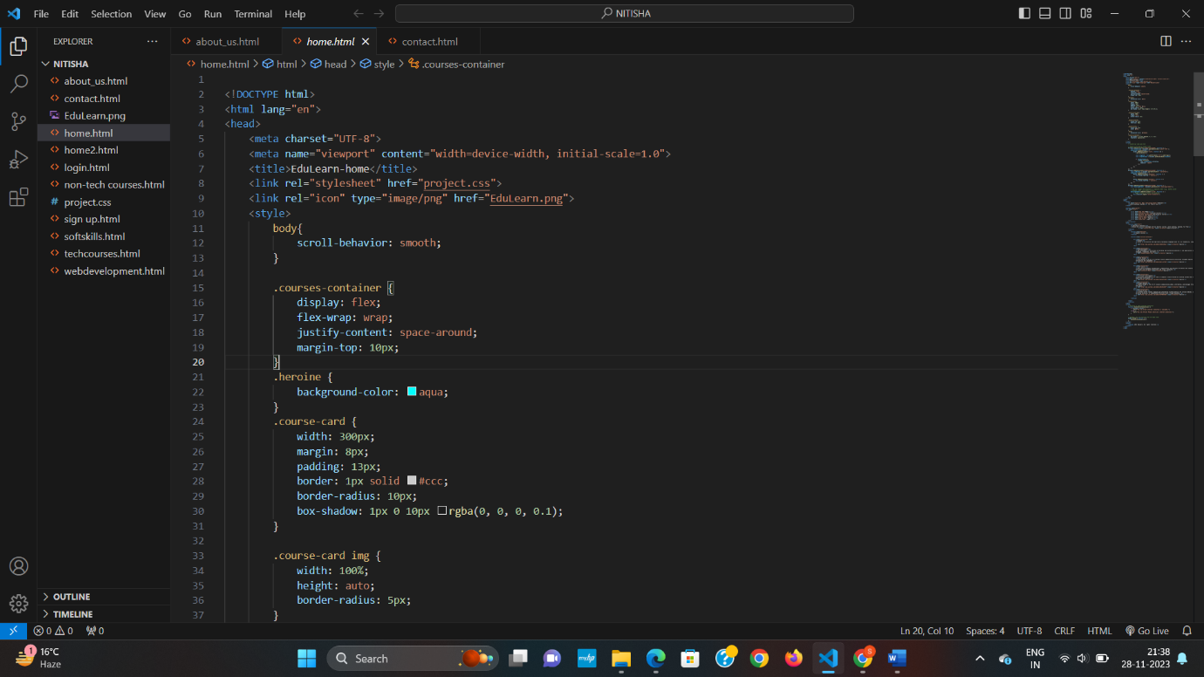Home Page

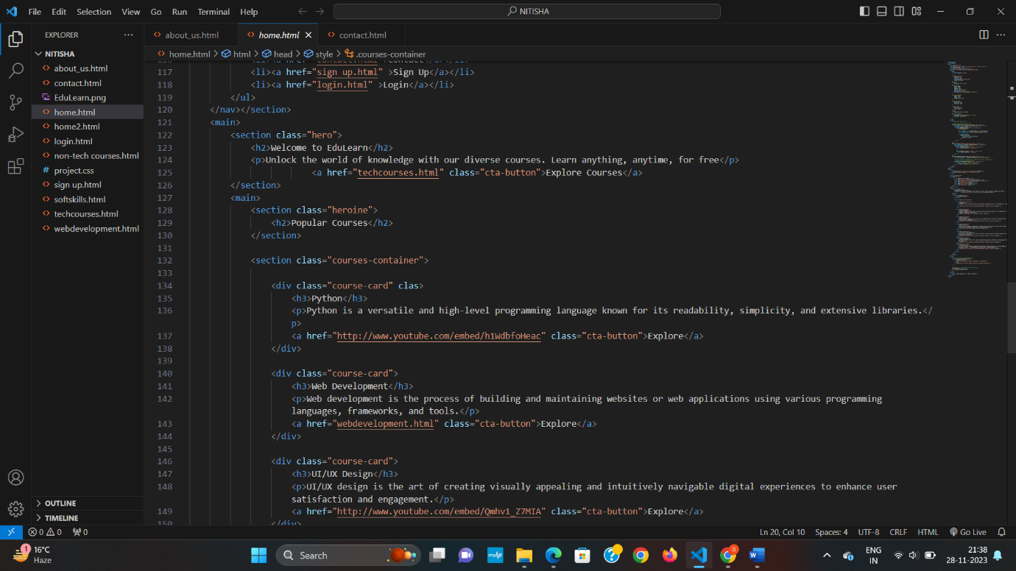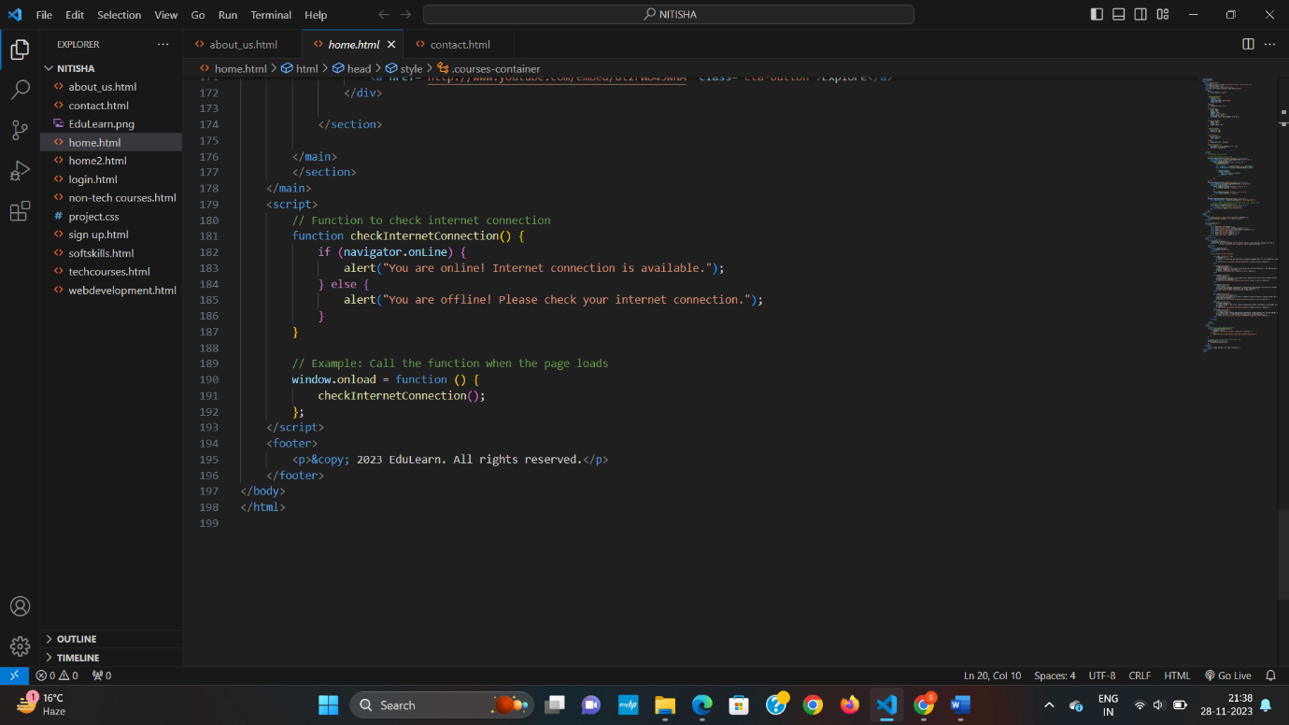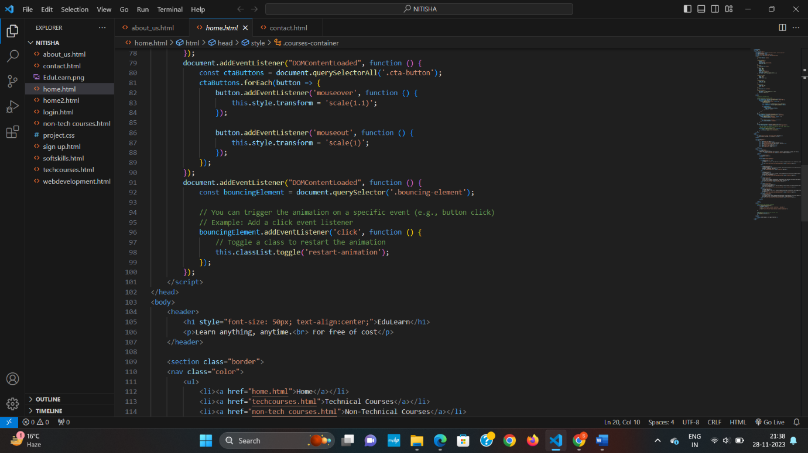



* 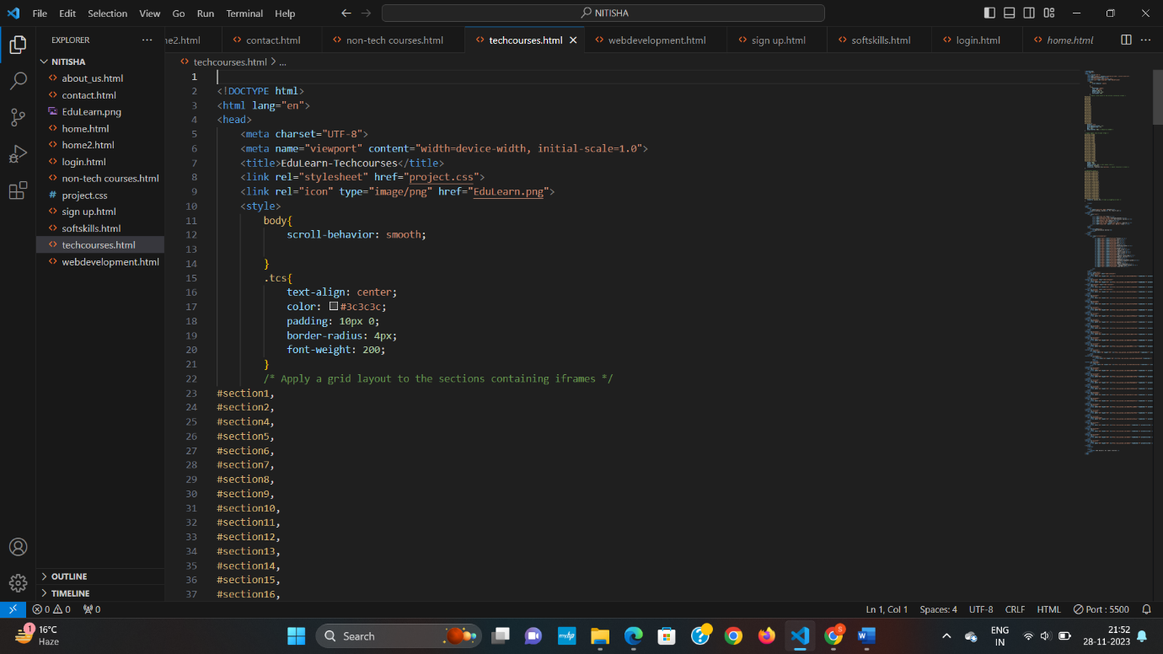Technical Courses:

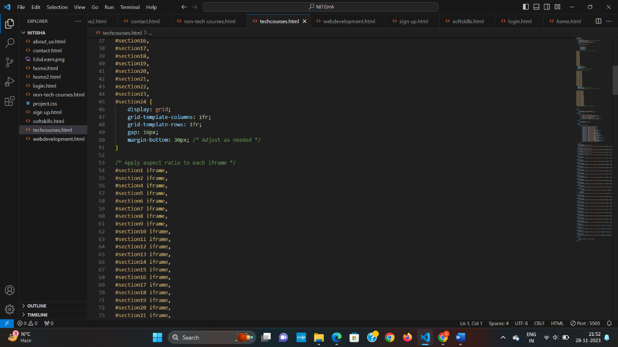

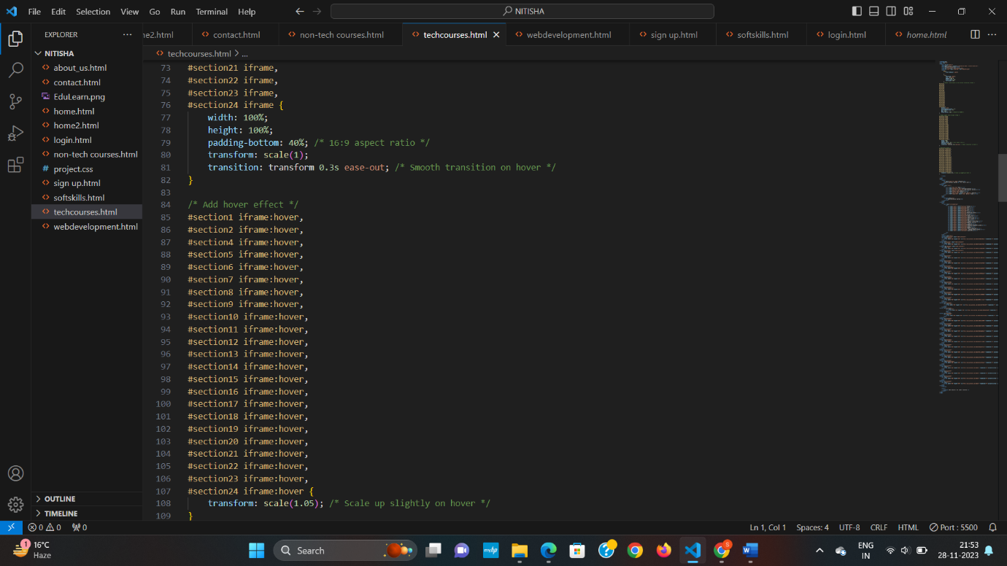

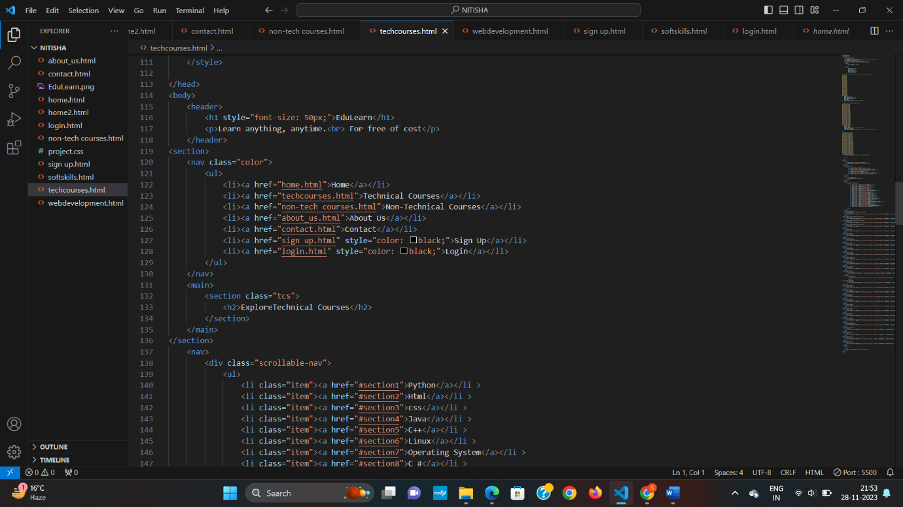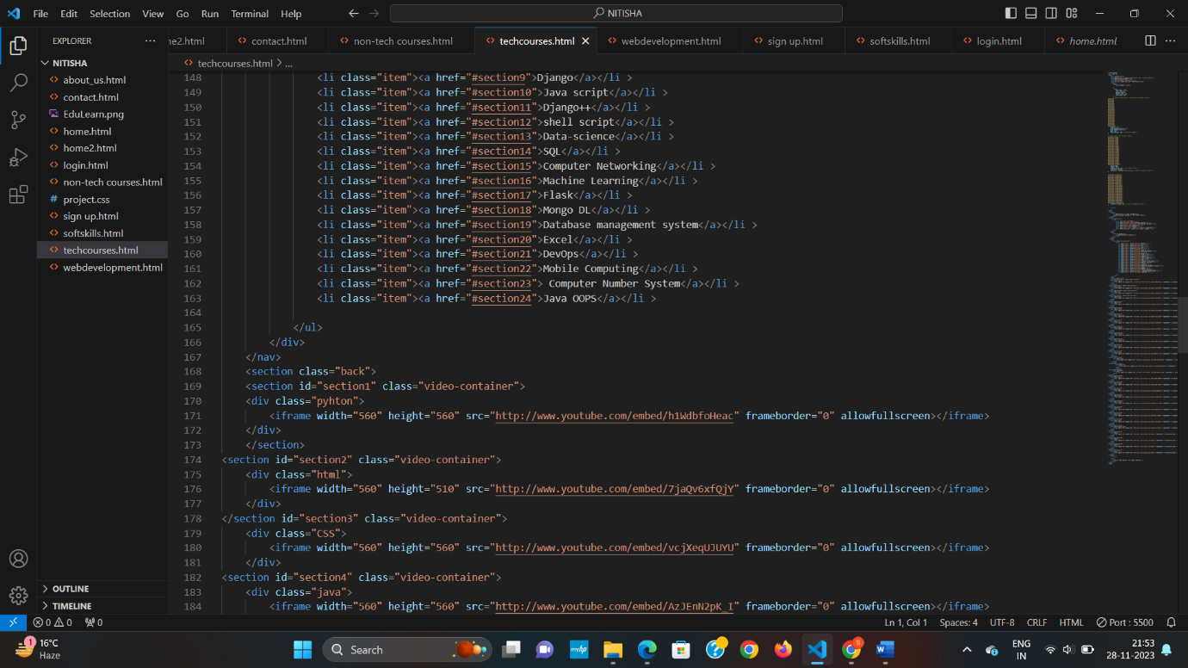

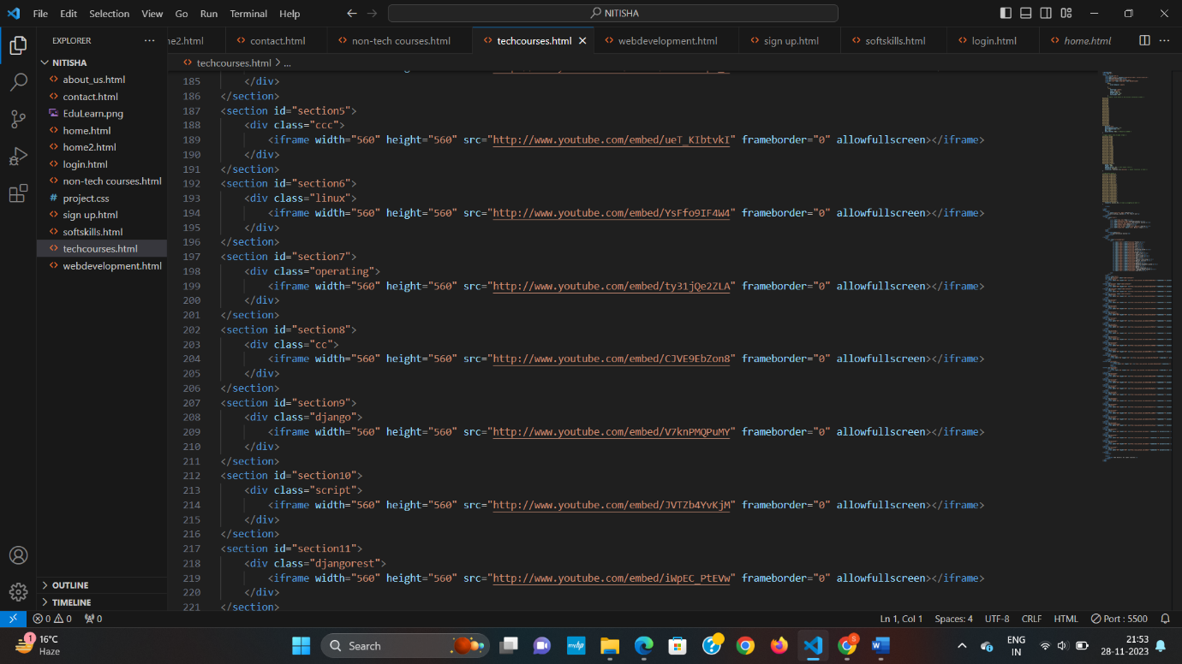

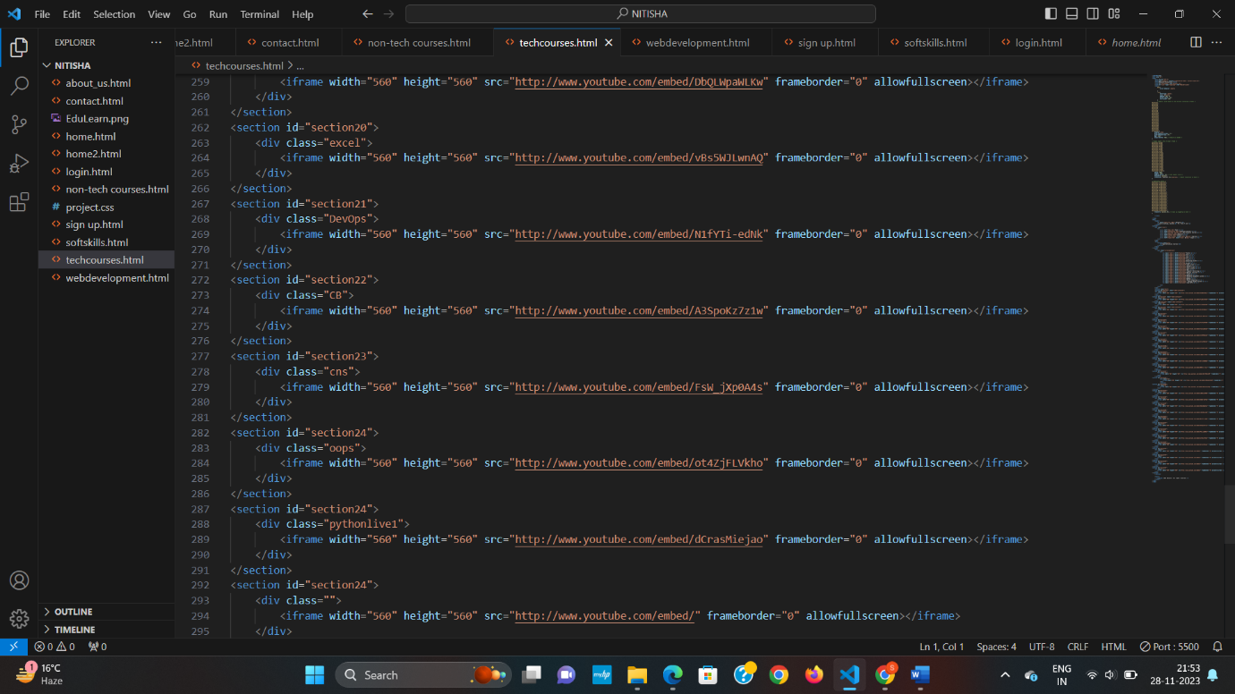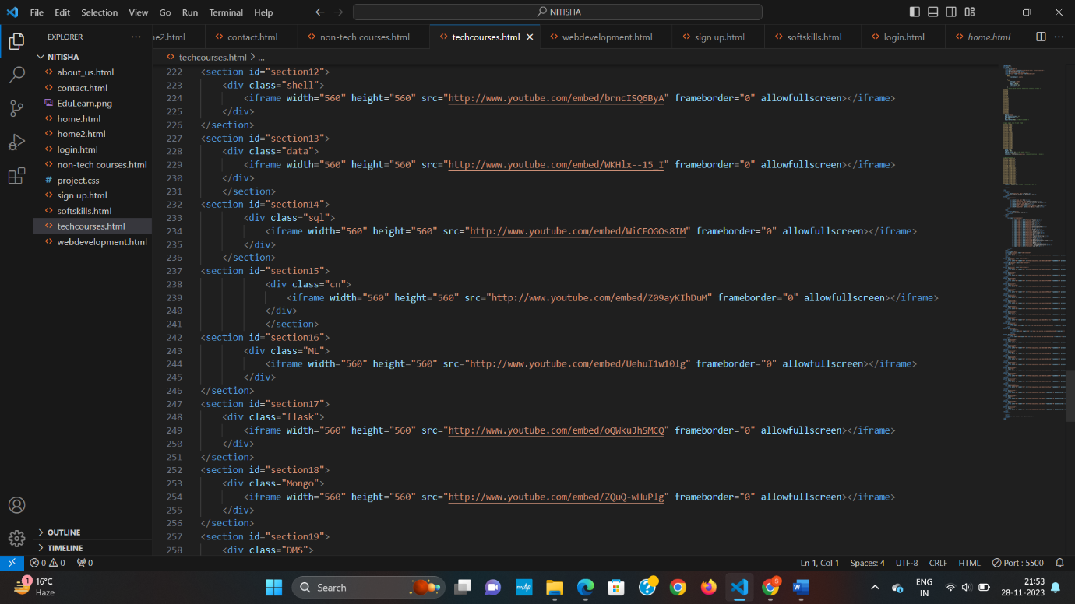

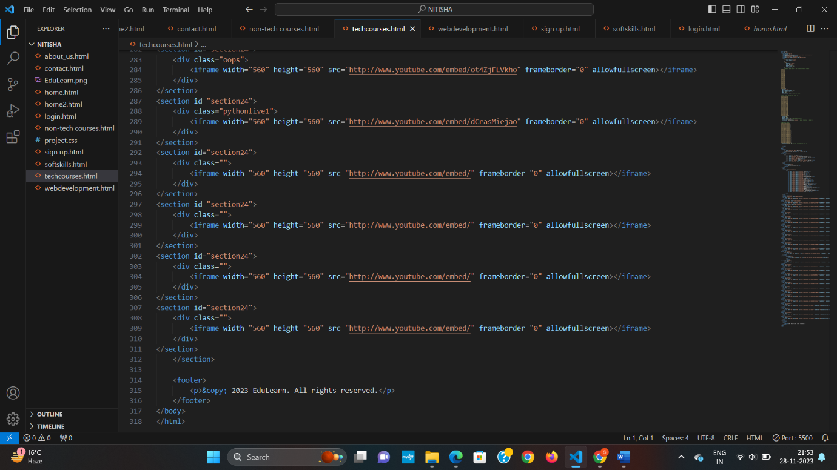

* Non Technical Courses

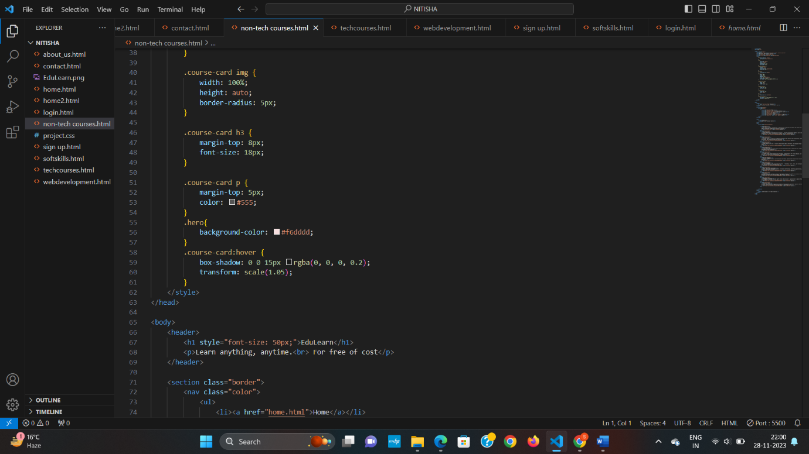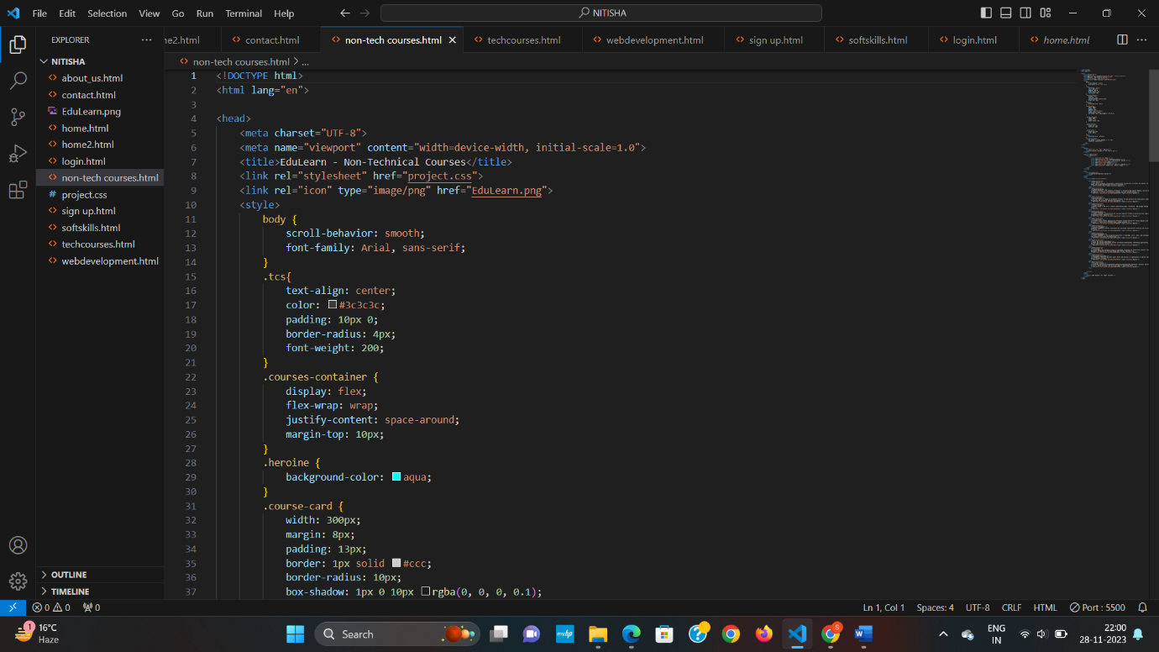

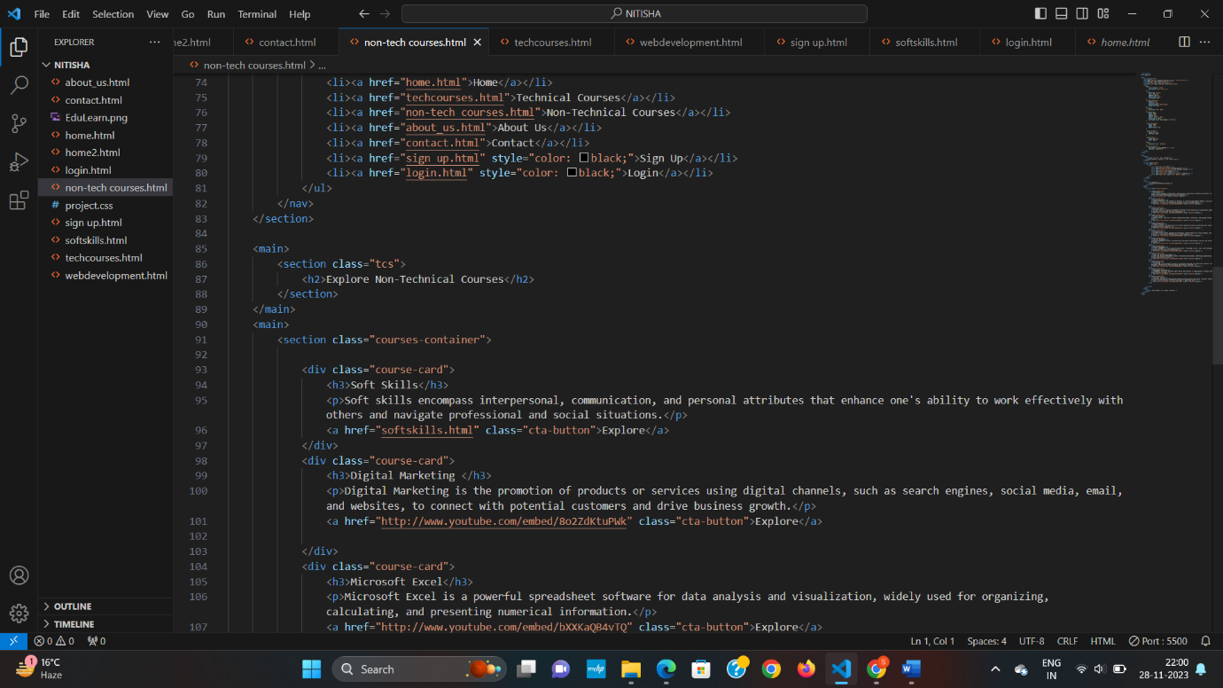

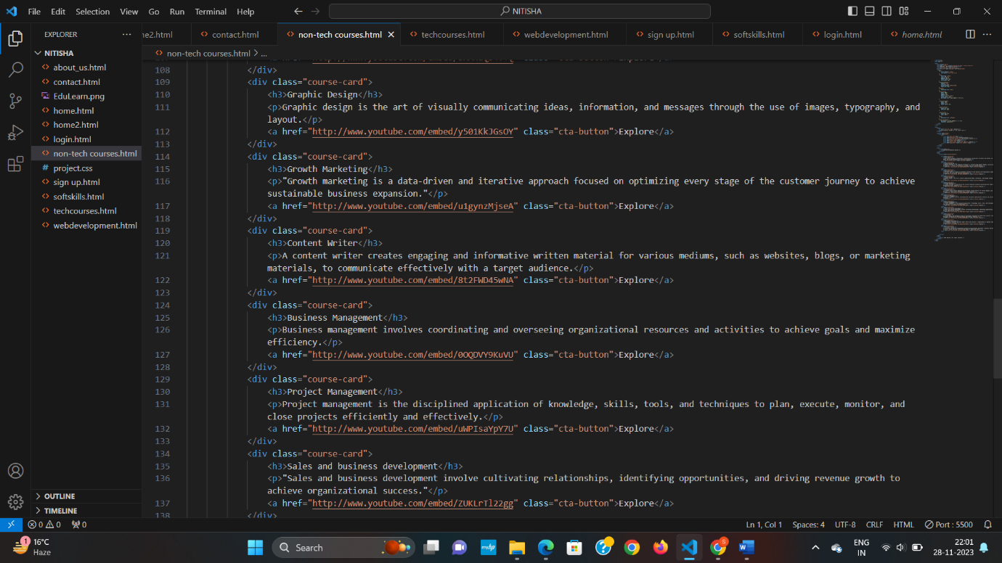

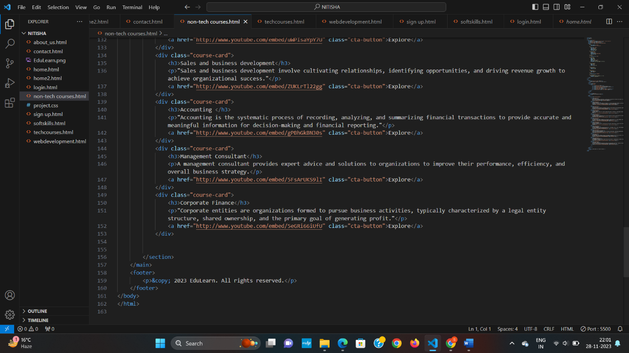

* 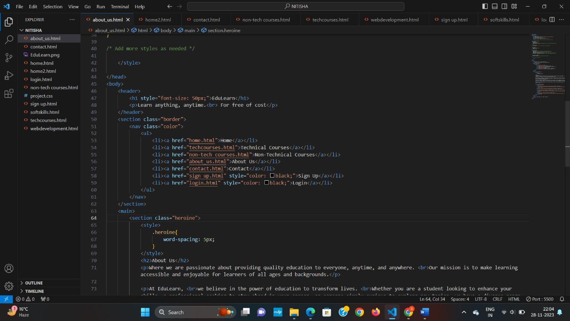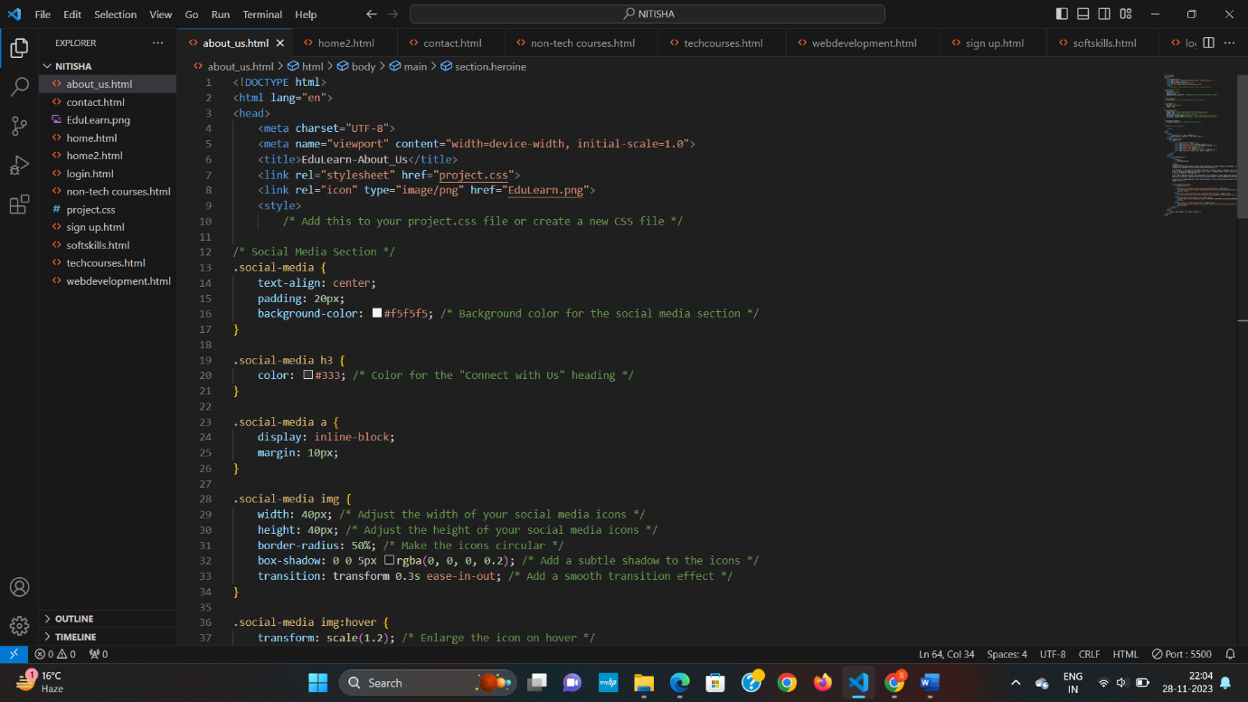About us

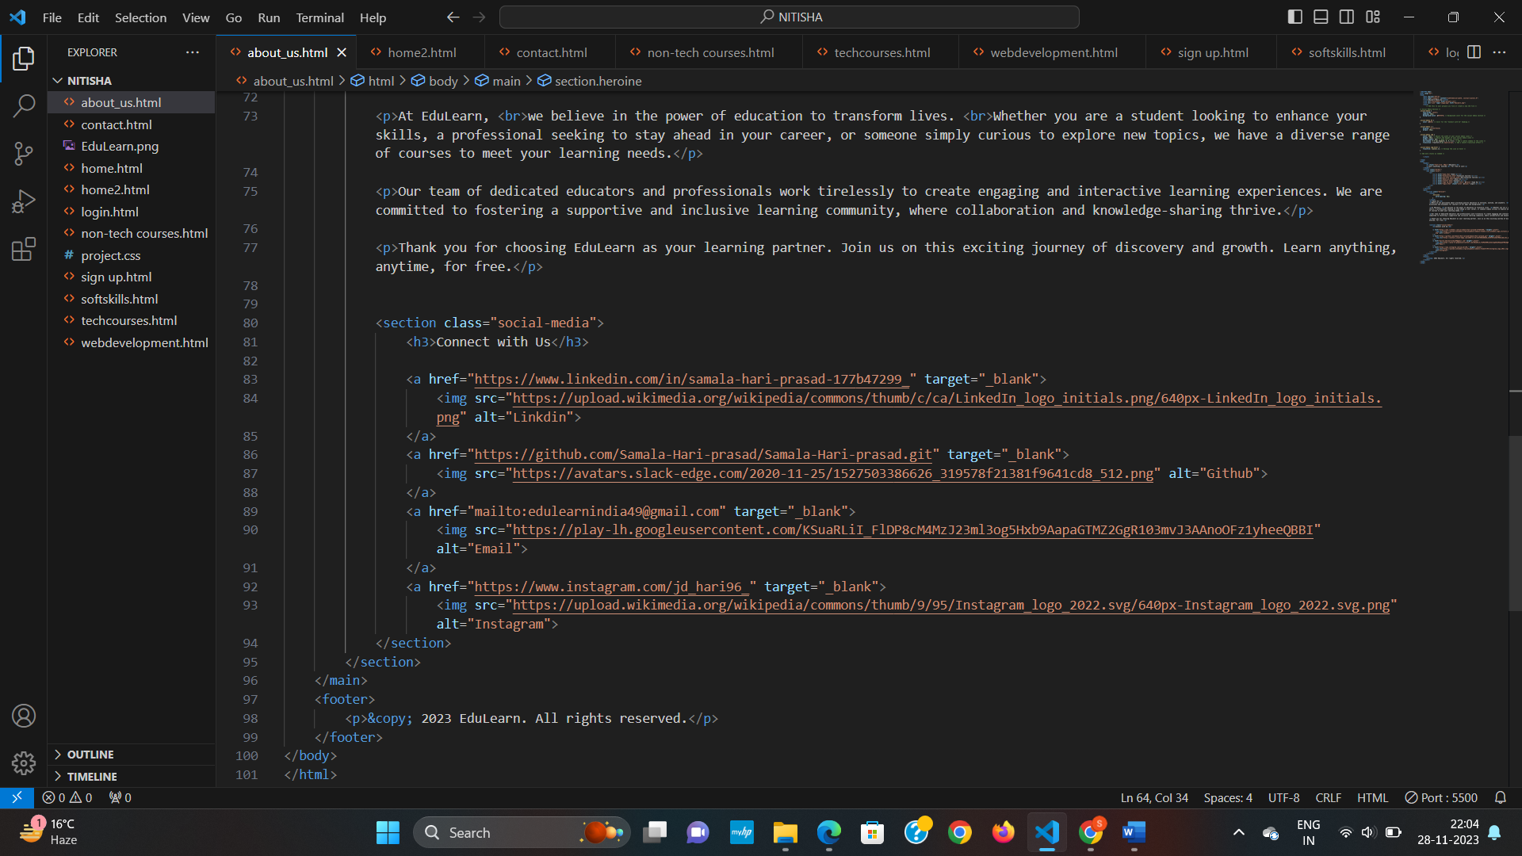

* 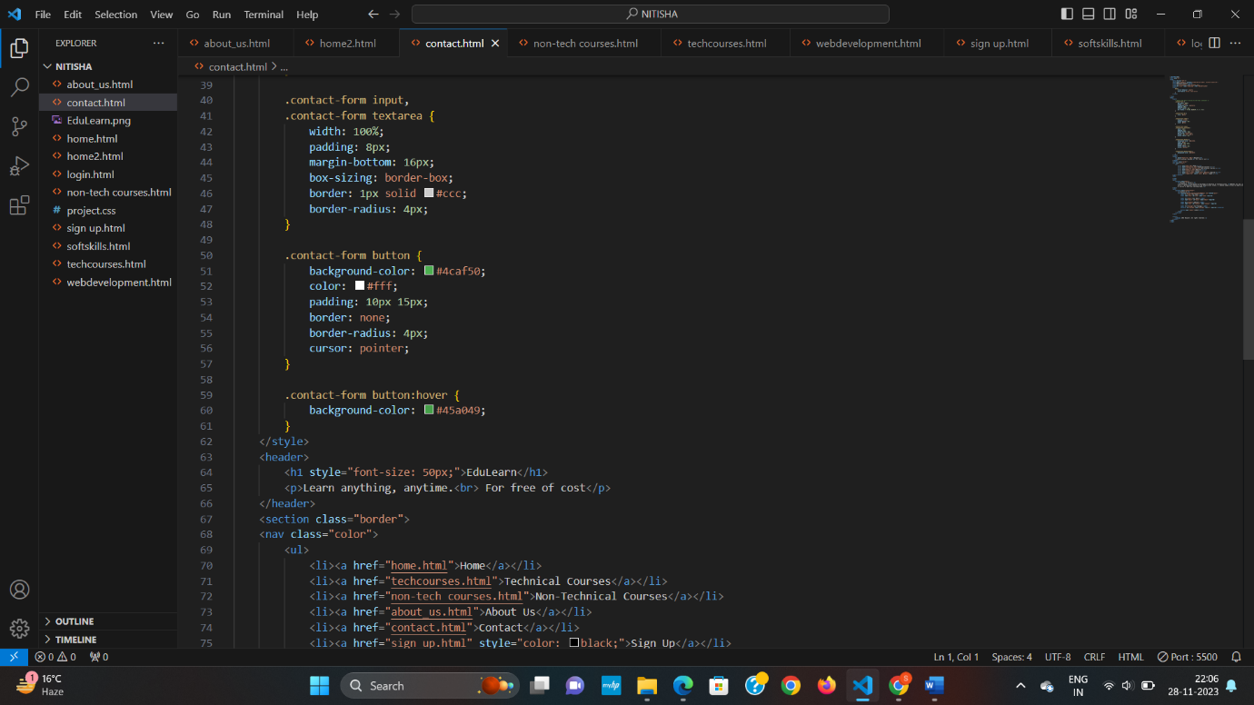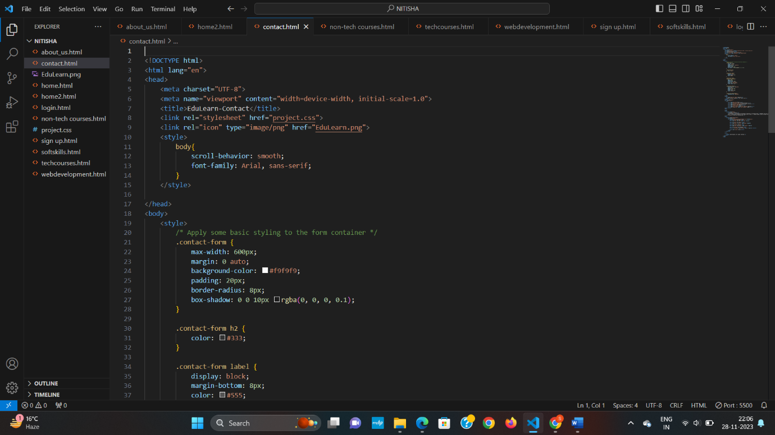Contact us

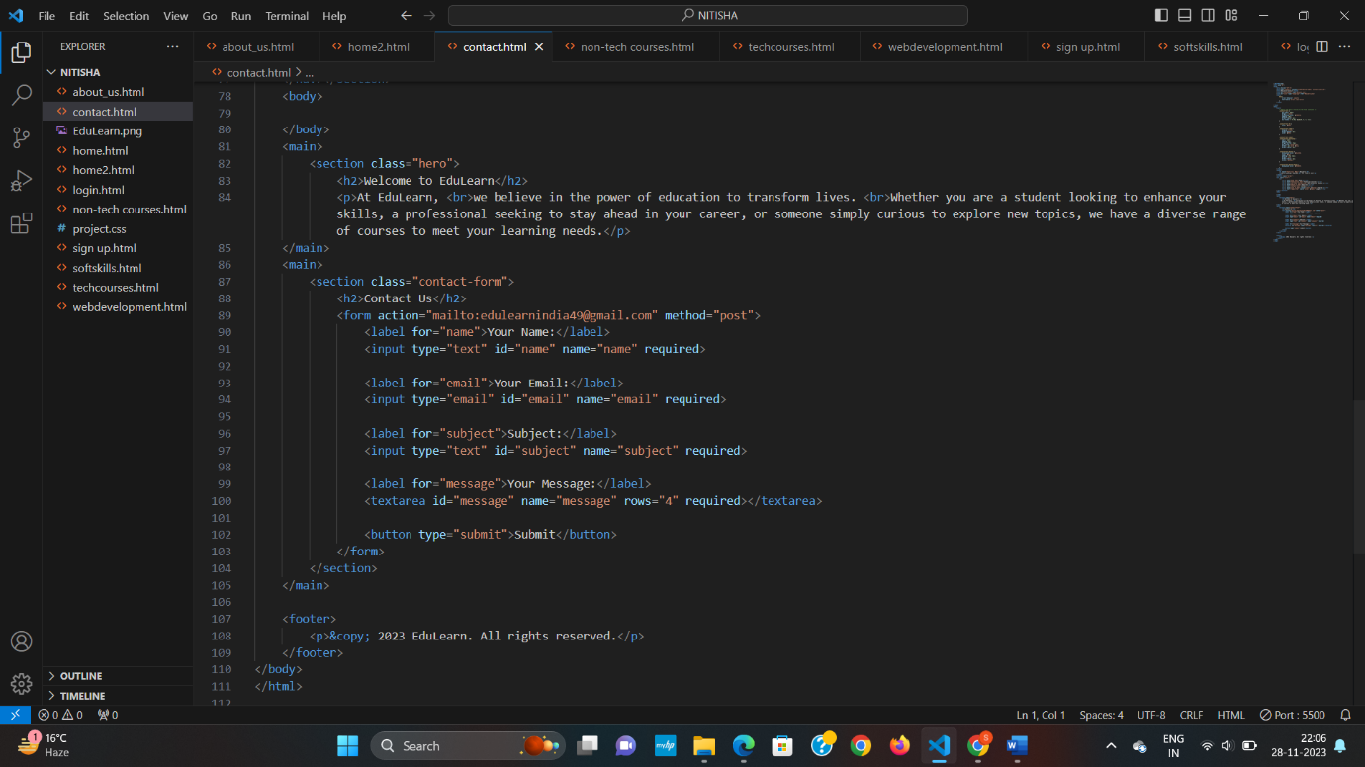

* 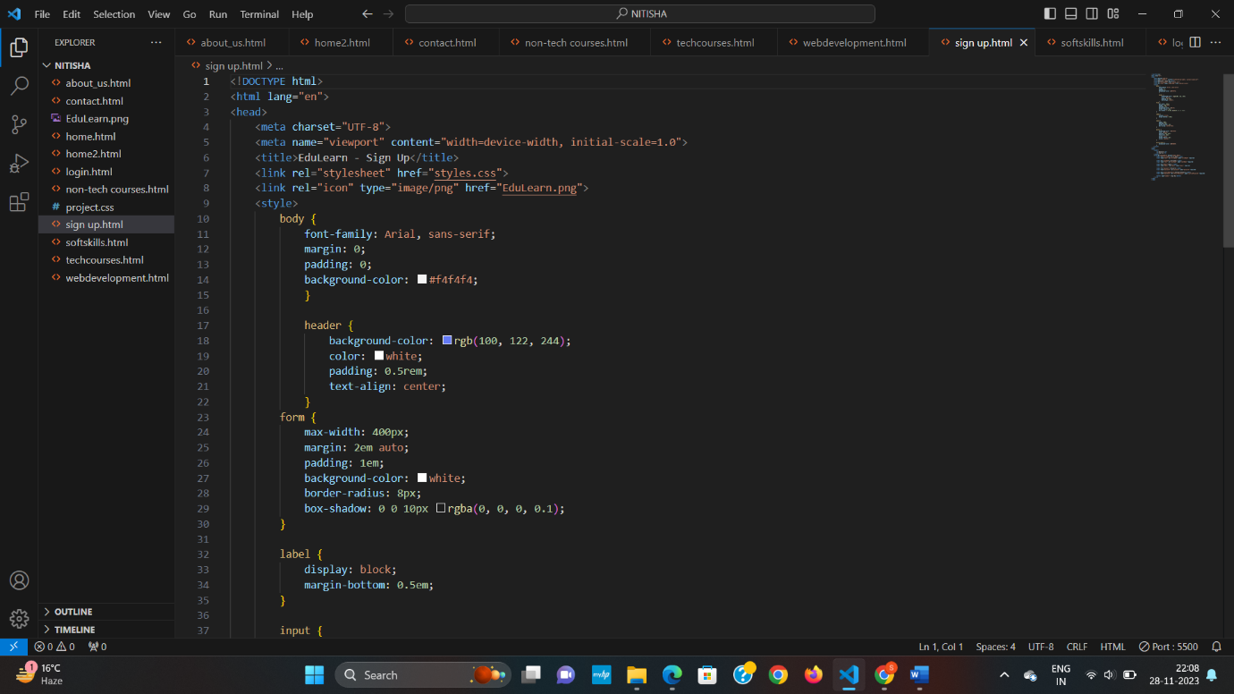Sign up

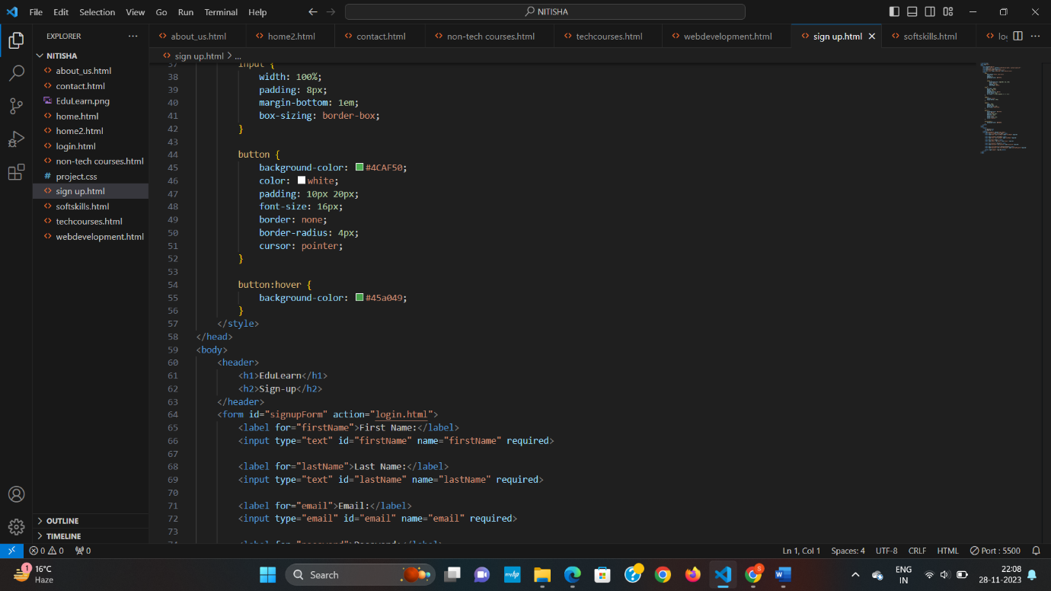

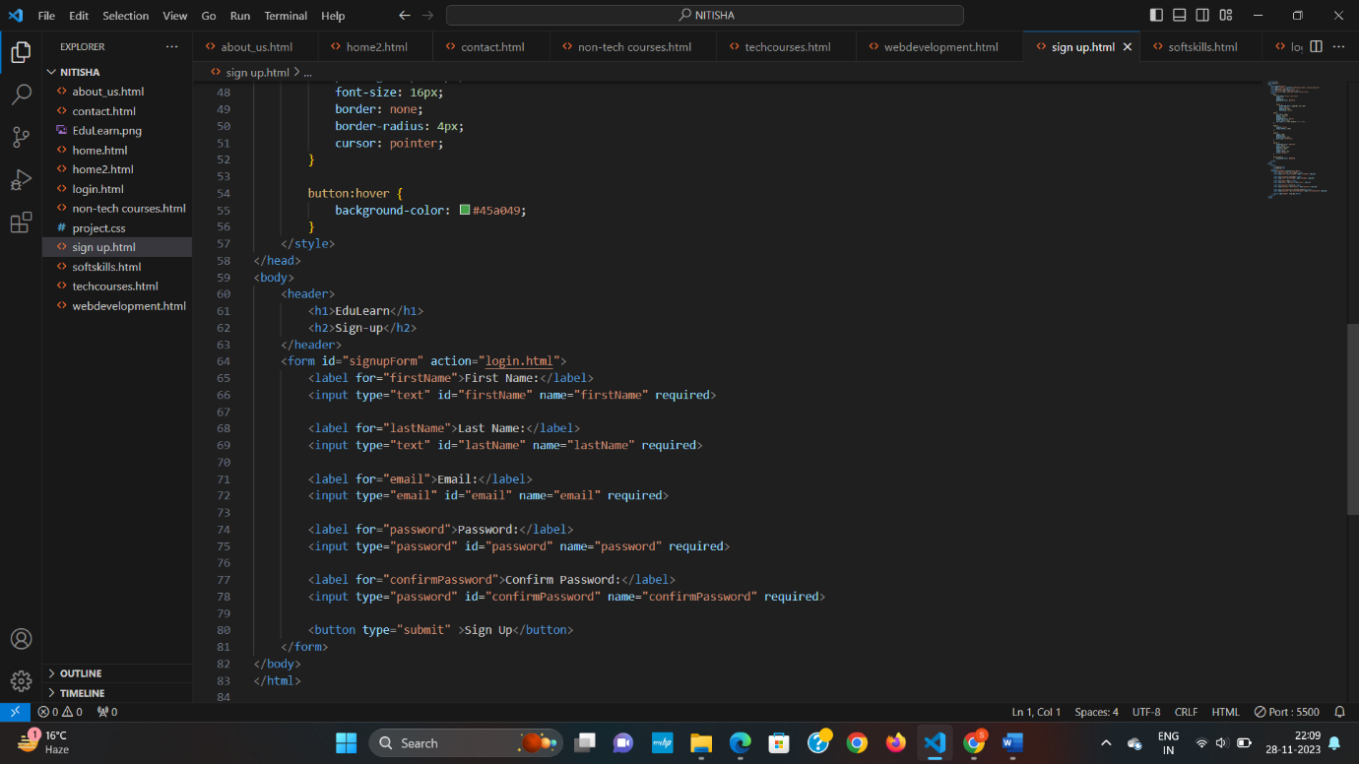

* 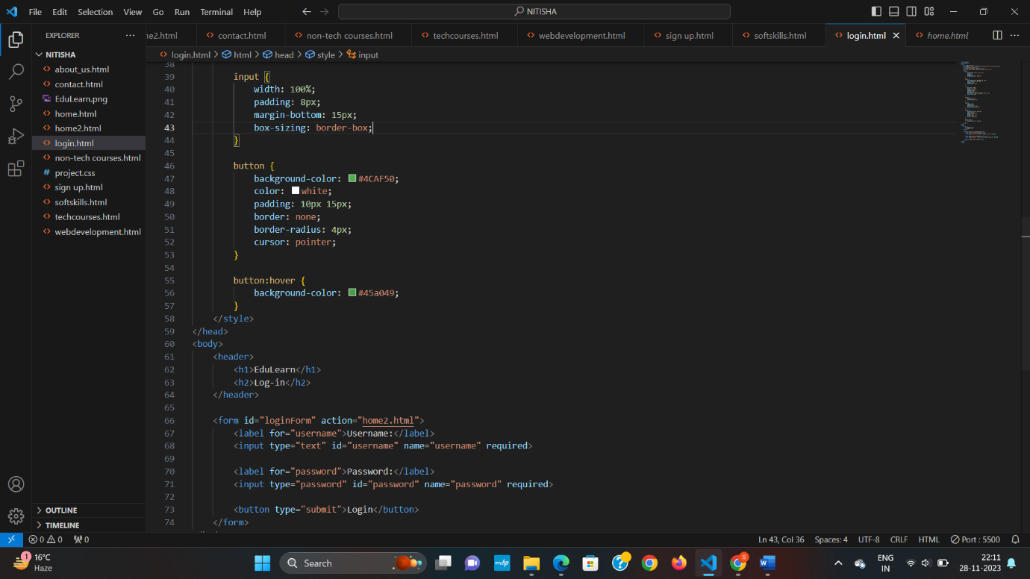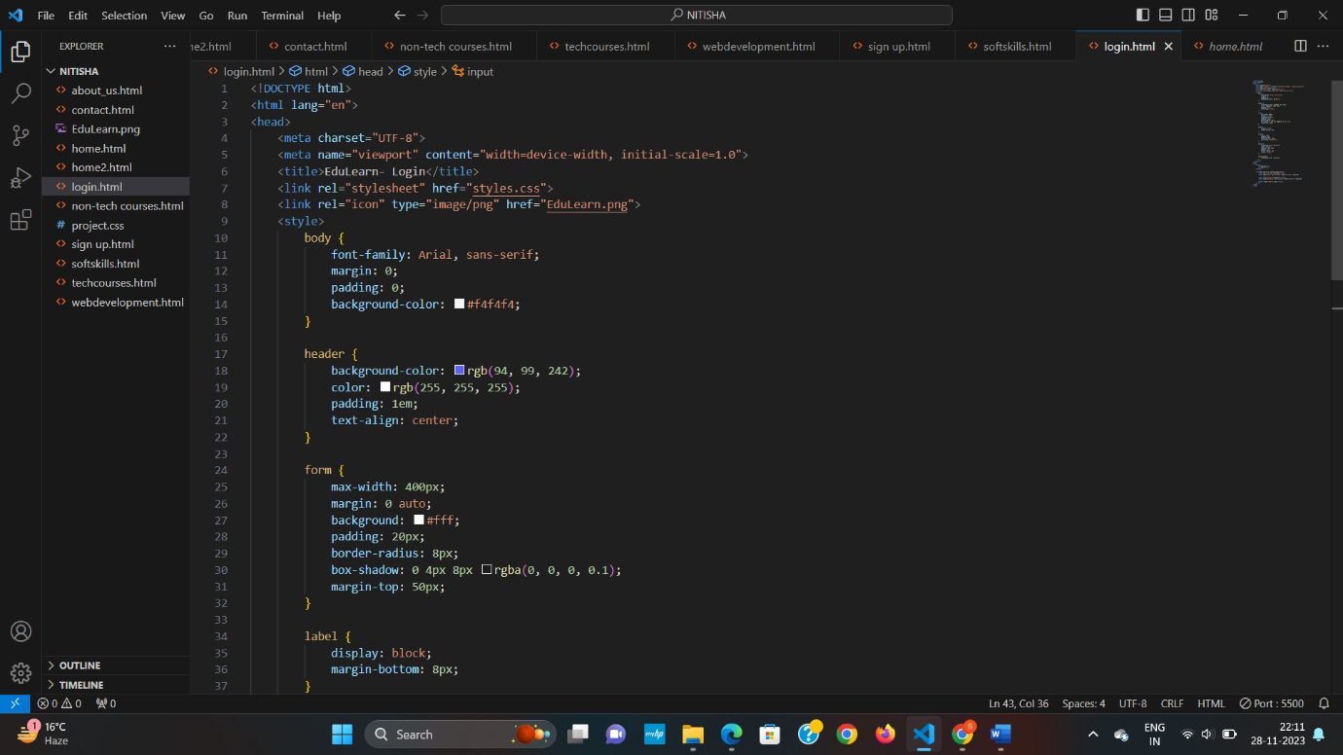Login

**References**

1. https://samala-hari-prasad.github.io/EduLearn/home
2. [https://www.w3schools.com](https://www.w3schools.com/)
3. [https://opoenai.com](https://opoenai.com/)
4. [https://stackoverflow.com](https://stackoverflow.com/)